**Dark Launch with Istio**

* Let’s assume we would want to release the new version of application/component and only certain users have to use this new release
* To demonstrate this let’s use two versions of v1, v2 of reviews application 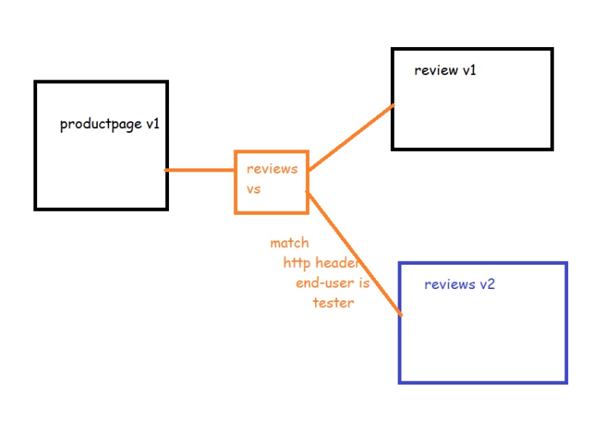
* <https://github.com/asquarezone/ExpertKubernetes/commit/962ef8494304497e38ed1f110f470d35bb399ebf> for the changeset
* Deploy the application from v3 folder

Normal user view 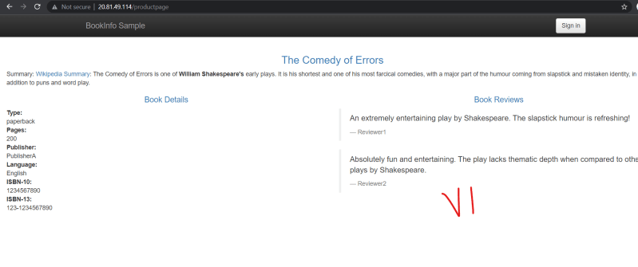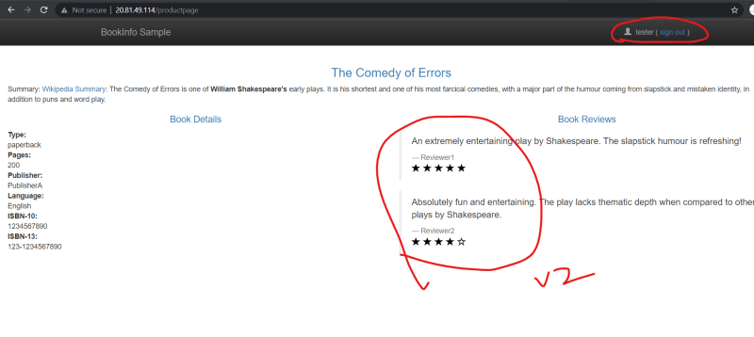

**Blue Green Deployment**

* Basic steps involed 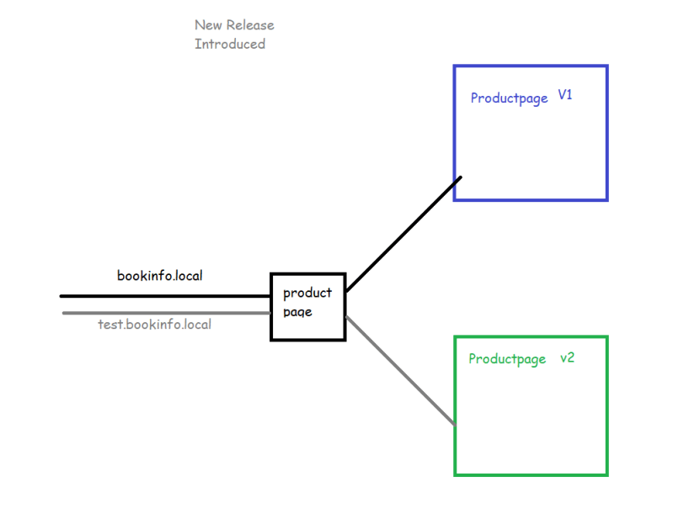

To demonstrate this lets try to create a new version for product page <https://hub.docker.com/r/shaikkhajaibrahim/productpage>

shaikkhajaibrahim/productpage:v2

<https://github.com/asquarezone/ExpertKubernetes/commit/722bccd02a99927f8367730a43cf03706568fe89> for the changes

Now apply the deployment.

Try to access using <http://bookinfo.com> (after adding entries into dns) 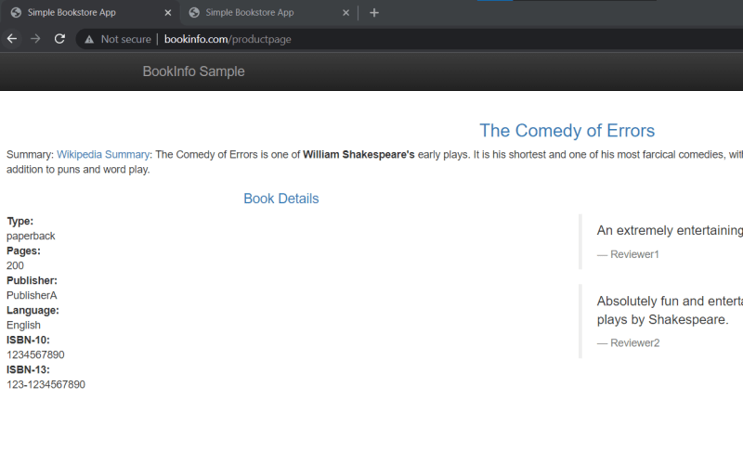

Try to access using <http://test.bookinfo.com> (after adding entries into dns) 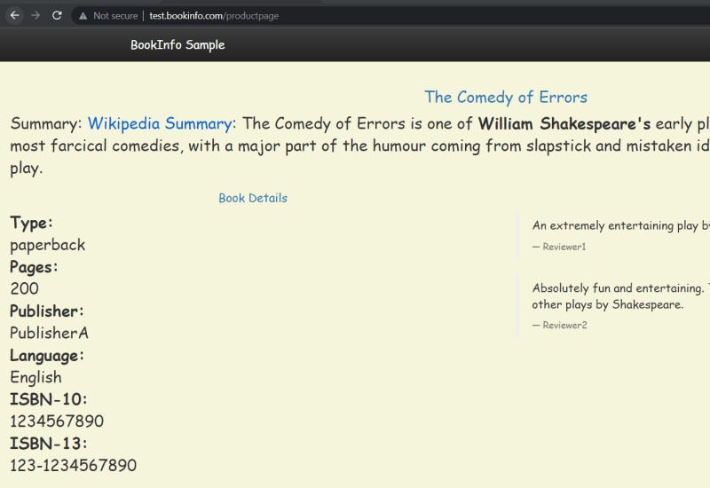

Now we have added simple files to move to new version for all the users and roll back to previous version in case of issues <https://github.com/asquarezone/ExpertKubernetes/commit/8361174c39ce472bc6bf878619411f5ac529212d>

Moving v2 to all the users 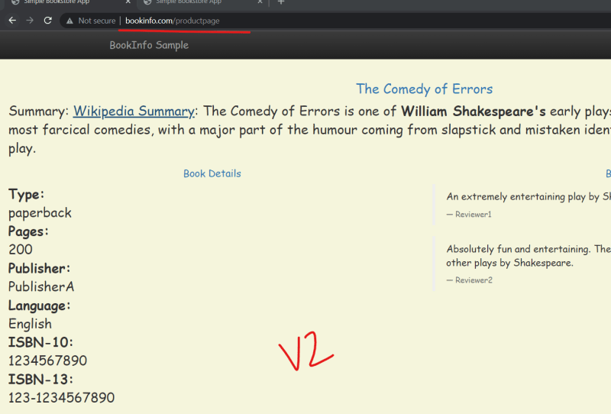

Exercise: Create a Canary deployment of the product page using the two versions.